Section C: Mini Project
CREATE TABLE users ( user_id INT PRIMARY KEY, name VARCHAR(50), email VARCHAR(100), created_at DATE );
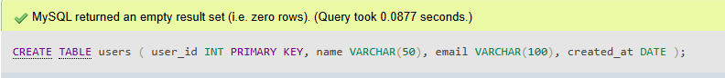

CREATE TABLE categories ( category_id INT PRIMARY KEY, category_name VARCHAR(50) );
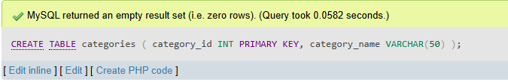

CREATE TABLE expenses ( expense_id INT PRIMARY KEY, user_id INT, category_id INT, amount DECIMAL(10,2), expense_date DATE, FOREIGN KEY (user_id) REFERENCES users(user_id), FOREIGN KEY (category_id) REFERENCES categories(category_id) );
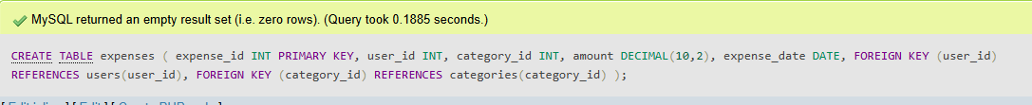

INSERT INTO users VALUES (1, 'Rahul Sharma', 'rahul@gmail.com', '2026-01-10'), (2, 'Priya Patel', 'priya@gmail.com', '2026-02-15'), (3, 'Amit Joshi', 'amit@gmail.com', '2026-03-20');
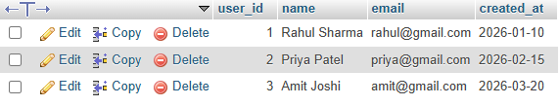

INSERT INTO categories VALUES (1, 'Food'), (2, 'Travel'), (3, 'Shopping');
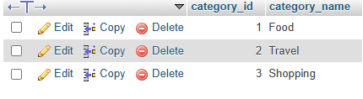

INSERT INTO expenses VALUES (101, 1, 1, 500.00, '2026-05-01'), (102, 1, 2, 1200.00, '2026-05-03'), (103, 2, 1, 300.00, '2026-05-04'), (104, 2, 3, 2500.00, '2026-05-05'), (105, 3, 2, 1500.00, '2026-05-06');
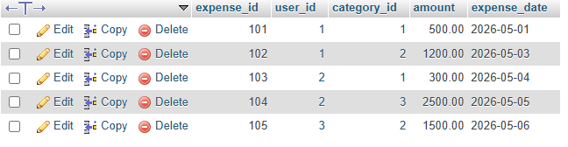

-- CRUD OPERATIONS
1. INSERT INTO expenses VALUES(106, 1, 3, 800.00, '2026-05-10');
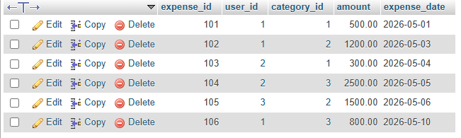
2. SELECT * FROM expenses;
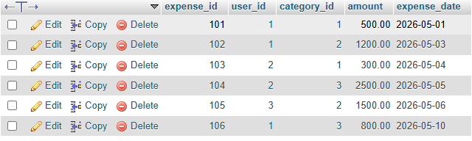
3. UPDATE expenses SET amount = 1000.00 WHERE expense_id = 106;
4. DELETE FROM expenses WHERE expense_id = 106;
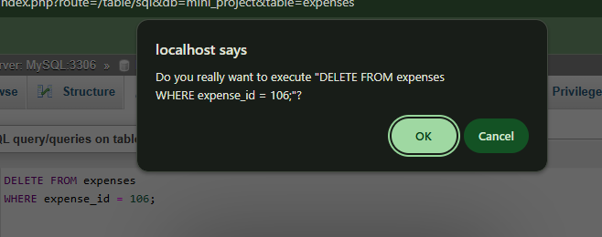

INNER JOIN QUERY
SELECT e.expense_date, e.amount, u.name, c.category_name FROM expenses e INNER JOIN users u ON e.user_id = u.user_id INNER JOIN categories c ON e.category_id = c.category_id;
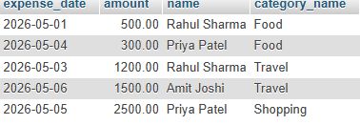

TOTAL EXPENSE PER CATEGORY
SELECT c.category_name, SUM(e.amount) AS total_expense FROM expenses e INNER JOIN categories c ON e.category_id = c.category_id GROUP BY c.category_name;
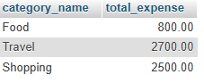
USERS SORTED BY TOTAL SPENDING
SELECT u.name, SUM(e.amount) AS total_spending FROM users u INNER JOIN expenses e ON u.user_id = e.user_id GROUP BY u.name ORDER BY total_spending DESC;
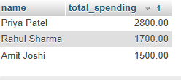
-- VIEW
CREATE VIEW ActiveUsersView AS SELECT u.name, u.email FROM users u INNER JOIN expenses e ON u.user_id = e.user_id GROUP BY u.user_id, u.name, u.email HAVING COUNT(e.expense_id) > 5;
-- VIEW QUERY
SELECT * FROM ActiveUsersView;


-- STORED PROCEDURE –
Calculate Monthly User Expense
DELIMITER $$
CREATE PROCEDURE GetMonthlyExpense(
IN p_user_id INT,
IN p_month INT,
IN p_year INT
)
BEGIN
SELECT
u.name,
SUM(e.amount) AS total_monthly_expense
FROM expenses e
INNER JOIN users u
ON e.user_id = u.user_id
WHERE e.user_id = p_user_id
AND MONTH(e.expense_date) = p_month
AND YEAR(e.expense_date) = p_year
GROUP BY u.name;
END $$
DELIMITER ;
-- CALL PROCEDURE
CALL GetMonthlyExpense(1, 5, 2026);
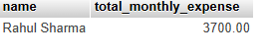

-- COMMIT EXAMPLE
START TRANSACTION;
INSERT INTO expenses VALUES
(111, 3, 1, 650.00, '2026-05-12');

COMMIT;

SELECT * FROM expenses;
CHECK DATA
SELECT * FROM expenses;
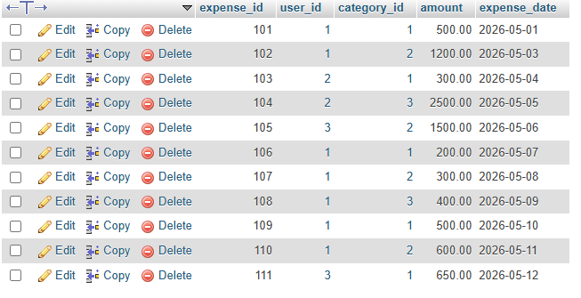

ROLLBACK EXAMPLE

START TRANSACTION;

INSERT INTO expenses VALUES
(112, 2, 2, 900.00, '2026-05-13');

ROLLBACK;
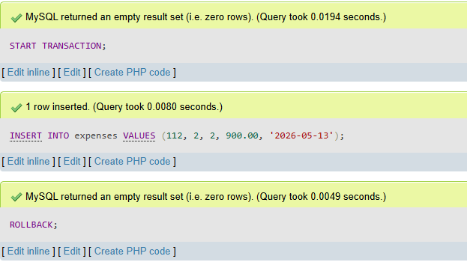

SELECT * FROM expenses;

